Literature Chair Report October 2025

The 3rd Quarter book order was placed with Central Office on 9/20/2025. Unfortunately, I over ordered 40 AA In Prison’s, and 20 As Bill See’s it, and did not order 120 12x12. Fortunately, Central office took 60 12 x 12 out of their inventory and will order another 60 this coming week to fully fill TAC’s 3 Q order which cost estimate with Grapevines was 7767.40. I donated the cost of the 60 books over buy to TAC. So, all will be well with my oversight when the last 60 12x12’s arrive this month. Central Office billed for the full amount including the 60 12 x12’s to be received.

The shipment was received, stamped and ready to go. Gail assisted in receiving and stamping the books. I gave her a key to the closet in case I am out of town and something comes up.
Below is the order I placed, excluding the 40 AAIP and 20 ABSI.
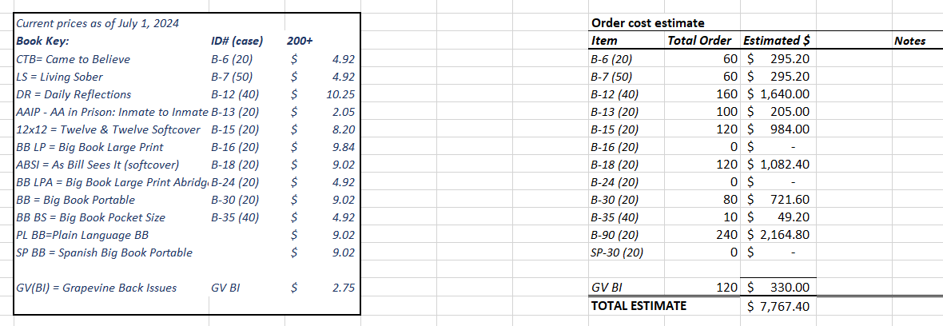

Current inventory per sign out sheets as of 10/16/25
GV 120
B-6 Came to Believe 6
B-7 Living Sover 95
B-12 Daily Reflections 130
B-13 AA In Prison 133
B-15 12x12 86
B-16 BB Large Print Full 5
B-18 AS Bill See’s It 148
B-24 BB LP Abridged 41
B-30 Big Book soft 163
B-35 Big Book pocket 10
B-90 Plain Language BB 240
SP-30 Spanish BB soft 14

Thank you,
Lori W.
TAC Literature Chair

