Accessibilities Report 9/16/26
BOOK RUN
- As part of the committee-approved plan- book bags were made, filled and are in-process of being delivered to 40 facilities by myself and 10 non-TAC volunteers.
  - Mental Health, Shelters, Elderly
  - Books and pamphlets specific for segment.
  - See photo below (Shelter example) for what was included in bags. Elderly was large-print versions of AA books.
  - A briefing was held at my house for the volunteers Sept 13 where mission and questions were explained and bags were picked up.
  - Agreed upon deadline to have all bags delivered 9/25.
- Part II- working with CPC/PI
  - Lizzy connected me with Andrew with CPC/PI.
  - Once all the list is corrected based on deliveries, I am re-sending him the master list and he is going to have CPC/PI volunteers call in to each location as follow up.
  - They will answer any questions, arrange for onsite if needed, communicate any feedback to me, etc.
  - Normally, they would go first but timing did not work- I needed to get this done before end-of-sept.
- Future plans will be made/revised based on this first run.
- Onsite AA meetings should develop from this and I will need volunteers to help support this. I will let you know.
- Reimbursement for Bags and Labels: Bags 50pc $33.91 Labels $6.35= $40.26 I used stuff I had for postcards, business cards and other labels.
- 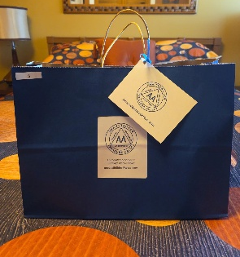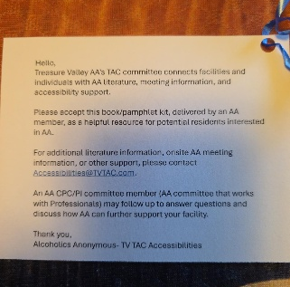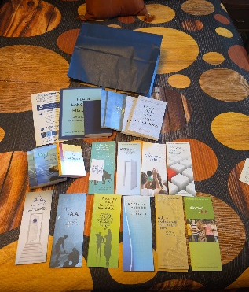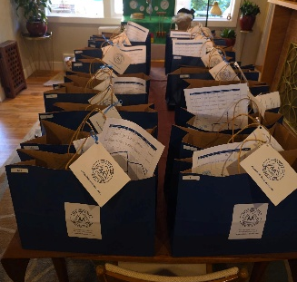

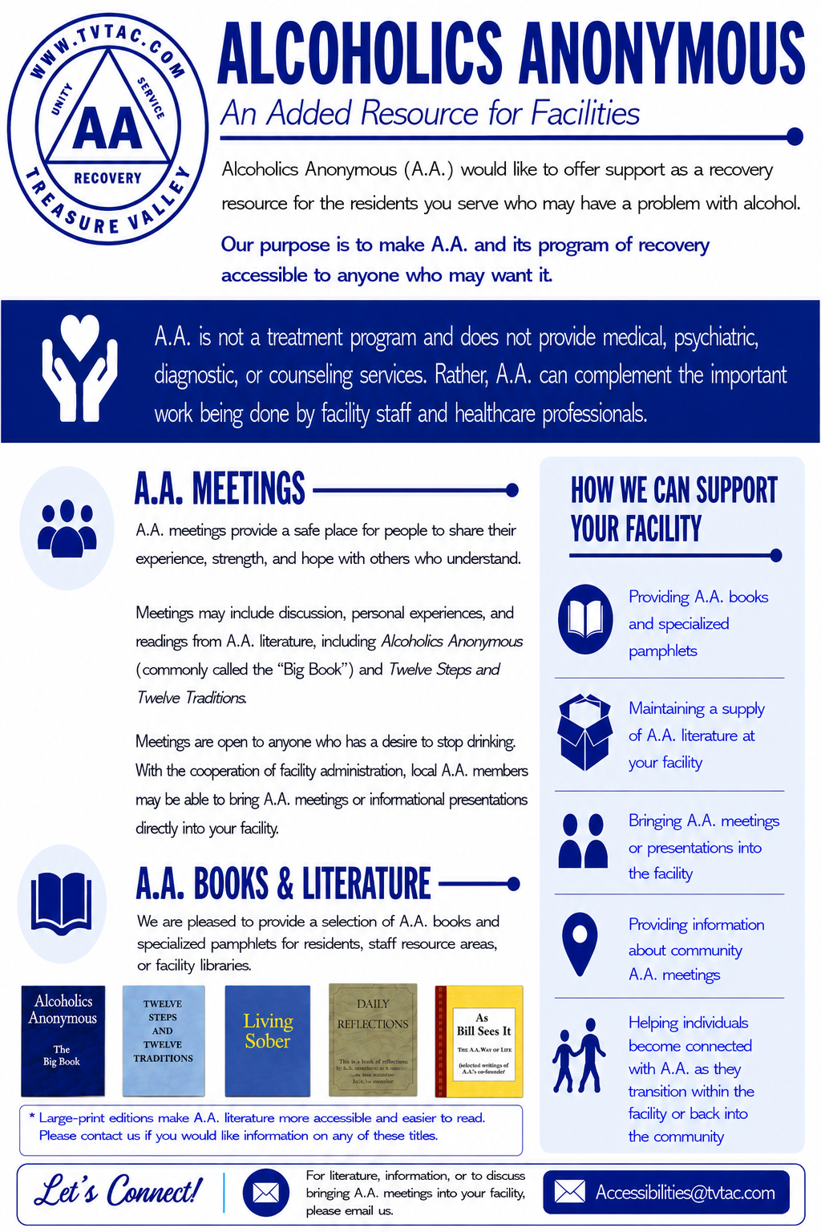
SPANISH OUTREACH
- I will be working with Vivian and Frank on this. No set plan has been developed at this time.
- Brainstorming session to take place soon, although I am super busy until end of year with work and personal so it might have to be Vivian and Frank coming up with best plan!

