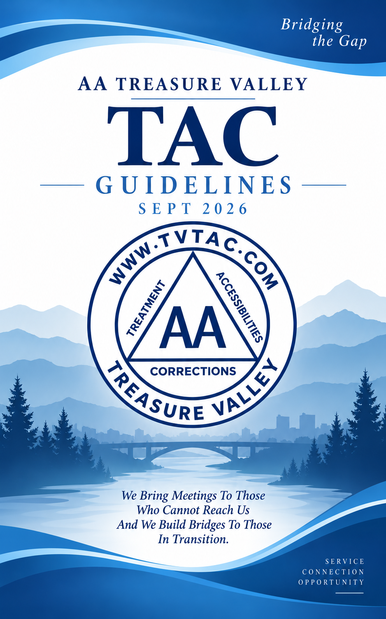

TABLE OF CONTENTS

SECTION PAGE

- DEFINITION 1
- PURPOSE 2
- RESPONSIBILITIES 2
- COOPERATION 2
- LITERATURE 2
- TREASURY/BANKING 5
- BUSINESS MEETINGS 7
- MEMBERSHIP 7
- VOTING 7
- ELECTIONS 7
- ELECTED OFFICERS 8
- OTHER COMMITTEE MEMBERS 16
- CONFERENCE/WORKSHOP ATTENDANCE/TRAVEL 19
- GUIDELINE AMENDMENTS 19
ATTACHMENTS
- MONTHLY TREASURER’S REPORT EXAMPLE 21

- ANNUAL FINANCIAL STATEMENT EXAMPLE 22

- VOLUNTEER TREATMENT GUIDELINES 23

- CORRECTIONS VOLUNTEER GUIDELINES 28

These Guidelines and Procedures are for the specific needs of the Treasure Valley Treatment, Accessibilities, and Corrections (TAC) Committee service work in the Treasure Valley area. For more information and guidelines on conducting meetings in treatment and correction facilities, we encourage members to read the workbooks and guidelines provided by the General Service Office of Alcoholics Anonymous (AA).
I. DEFINITION: The Treasure Valley TAC Committee is a part of Area 18. It is made up of volunteer members from AA groups in Districts 3, 4, 5, 8, and 9. If geographic challenges make it difficult for a member to participate in Treasure Valley TAC service work, we encourage that member to participate in a committee that is most convenient for them.
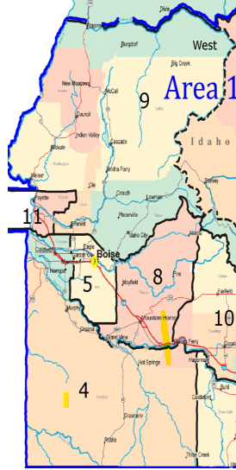

II. PURPOSE: TAC was created in harmony with AA’s Tradition Nine to unify the efforts of those doing 12 Step Work in treatment and correction facilities and hospitals and to assist those with accessibility needs.
III. RESPONSIBILITIES: TAC operates within the guidelines of the AA General Service Office. These guidelines and procedures for the conduct of TAC meetings have been adapted to better coordinate activities by clearly defining the responsibilities of members and the duties and succession procedure for officers.

Type to enter text
TAC assumes no responsibility for any individual member conducting a meeting within a facility. We remind volunteer members that we are guests of the facility and, therefore, must comply with the procedures of that facility while acting within the boundaries of our 12 Traditions and 12 Concepts.
IV. COOPERATION: TAC provides AA services to a facility at the invitation of that facility’s administration. While at a facility we must always be mindful of our tradition of “cooperation” and not “affiliation”. A member or volunteer of TAC does not represent AA as a whole.
V. LITERATURE: Only AA approved literature, media, and AA Grapevine magazines may be taken into facilities served by TAC. Literature is distributed according to the Literature Issue Policy.
A. LITERATURE ISSUE POLICY: Literature is distributed pursuant to a majority vote of the Committee and on a funds-available basis in the following proportions:
- PRISONS: The first priority is to distribute fifty percent (50%) of available resources to prisons as requested.
- JAILS AND TREATMENT CENTERS: The remaining fifty percent (50%) of available resources will be distributed to jails and treatment centers as requested.
B. LITERATURE PURCHASE AND DISTRIBUTION PRIORITIZATION:
- PRISONS AND JAILS:
- Any approved AA literature as requested and as permitted by the facility.
- NON-PROFIT HOSPITALS AND TREATMENT FACILITIES:
- Any approved AA literature as requested and as permitted by the facility.
- FOR-PROFIT FACILITIES:
a. TAC does not support literature to for-profit facilities. Literature can be purchased at TVICO.
- ACCESSIBILITY LITERATURE: Volunteers are encouraged to make AA accessibility literature available to the facilities they serve.
- SPECIAL SUPPORT-CASE LITERATURE: LIBRARY STARTER PACKAGE
TVTAC may provide a limited quantity of literature in the form of a Library Starter Package to non-profit or for-profit facilities when sufficient funds remain after all core TVTAC book orders and operating expenses have been met.
The purpose of the library is to support alcoholic residents at facilities which currently do not provide AA literature. This is not a facility outreach program and all facility requests must be presented by a TVTAC representative to the TVTAC committee. Each facility will be voted on and approved by TVTAC committee.
- This package is a single initial donation and will not be replenished by TVTAC.
- TVTAC will extend its volume discount pricing to the facility for any subsequent library replenishment orders placed directly by the facility.
The Library Starter Package will consist of the following titles with set quantities at an approximate $100 cost limit:
- Four (4) Alcoholics Anonymous (“Big Book”)
- Four (4) Twelve Steps and Twelve Traditions
- One (1) Daily Reflections
Variations of the books in this package may be approved by the committee and must stay within the $100 cost limit.
The quarterly financial spend on Library Starter Packages will not exceed $500. At the end of each quarter, TVTAC will assess funding to determine how much (if any) can be allocated towards Library Starter Packages for the following quarter.
Pink Can & Event money will not be used to fund Library Starter Packages as this funding is strictly dedicated to the purchase of literature for Treatment, Accessibilities, and Correction facilities.
VI. TREASURY/BANKING: A bank account shall be maintained for the purpose of conducting TAC business. Opening, closing, or transferring the TAC bank account shall require two member signatures.
Electronic banking is authorized. The Committee Chair and Treasurer shall be issued debit cards for conducting TAC business as authorized by Committee vote or authorized by the annual budget.
- USE OF FUNDS: TAC funds will only be dispersed for carrying the AA message. Expenditures over one hundred ($100) dollars, not specifically approved in the budget, shall require prior approval of the Committee.
- TREASURER RESPONSIBILITIES: The Committee Chair, Treasurer, and one other member shall prepare and present a budget to the whole Committee at the October meeting which shall be distributed to all relevant groups for review and input. The budget shall be voted on at the November meeting. The approved budget shall be in effect for the calendar year beginning January 1 and ending on December 31 the following year. Approval of a budget does not guarantee that funds will be available for any given purpose or at any given time. Monthly treasurer’s reports shall be available to any AA member upon request or by posting on the TAC website.
- PINK CAN FUNDS: “Pink Can” funds are only to be used for Corrections and Treatment facilities and non-profit Accessibility facilities.
- TRAVEL FUND: A travel fund shall be a line item on the annual budget. The travel fund shall accrue at a rate of fifty ($50) dollars per month and be capped at six hundred ($600) dollars per calendar year. The funds may only be used for officers per calendar year to attend a conference or workshop that are pre-approved by the Committee at a regular meeting.
- PRUDENT RESERVE: In keeping with Concept 12, Warranty Two, a prudent reserve shall be maintained consisting of at least three months’ operating expenses, not including literature orders. The prudent reserve shall be included in the annual proposed budget as a separate line item. The Prudent Reserve shall only be used for expenses specifically authorized in these Guidelines.
- ANNUAL BBQ/PICNIC: One Thousand ($1000) dollars in seed money for the annual BBQ shall be provided as a separate line item in the annual budget. Seed money shall only be used for event expenses, including but not limited to: park rental, tickets, food and beverages, flyers, and other advertising. The BBQ committee shall elect a treasurer who shall be responsible for accounting for all BBQ funds and reporting to TAC no later than the regular meeting in the month following the BBQ. The Event Coordinator shall act as treasurer in the absence of an elected treasurer.
VII. BUSINESS MEETINGS: TAC business meetings shall be held once monthly (except December) at a time, place, and manner designated by the Committee membership. The Committee can choose to cancel or postpone any monthly meeting by a majority vote of those attending a business meeting. Business meetings shall be presided over by the Chair or another member of the TAC committee in the Chair’s absence.
VIII. MEMBERSHIP: TAC membership consists of all elected Officers of TAC, District TAC Representatives, Home Group TAC Representatives, TAC Facility Liaisons, TAC Facility Meeting Coordinators, and the TAC Cooperation with Professional Community/Public Information (CPC/PI) Liaison. Sobriety requirements for membership on the Committee are listed by position.
IX. VOTING: Only TAC members shall have a vote on Committee issues. Any AA member may participate in discussion at a Committee meeting. No proxy voting will be permitted at TAC business meetings.
X. ELECTIONS: Election of officers for TAC shall be held every two (2) years for Chairperson, Treasurer, Literature, Treatment and Bridging the Gap on odd-numbered years and shall be held every two (2) years for Secretary, Accessibilities, Corrections and Webmaster on even-numbered years at the regular November monthly business meeting. Elected officers shall take office at the January business meeting the following year.
A list of nominees shall be submitted to the Committee members at the regular October Committee business meeting. Nominations from the floor shall also be considered at the November election meeting. Voting shall be by written ballot or by electronic submission for each position with a simple majority deciding the winner.
XI. ELECTED OFFICERS: The elected officers of Treasure Valley TAC shall consist of the following:
- Chairperson
- Secretary
- Treasurer
- Literature Chairperson
- Accessibilities Chairperson
- Corrections Chairperson
- Treatment Chairperson
- Bridging the Gap/Temporary Contact Chairperson
- Webmaster

Elected officers must attend a minimum of eight (8) regular monthly business meetings within each calendar year of their term or they may be removed by a majority vote of the Committee at a regular meeting. Communication with the Chairperson or Secretary by telephone, email, or regular mail, accompanied by a written report for that month, shall be considered attendance for any regular monthly meeting.
An elected officer may resign at any time by giving written notice to the Chairperson. If the Chairperson is resigning, then written notice shall be given to the Secretary. Email or text is an acceptable form of written notice.
The Chairperson may name a person to replace any officer who becomes unable to discharge his/her duties of office for any reason. The appointed officer shall serve the remaining term of office of the person being replaced. Completion of a partial term by an appointee shall not be considered a term served for the purposes of term limits.
The Committee may choose instead to conduct an election to replace any officer who has not met the requirements for continuing as an officer or to fill an open position.
A. TERM LIMITS: In the spirit of rotation, no person shall be elected to more than one (1) term of service for the same position without a majority vote of the Committee at a regular meeting.
B. RESPONSIBILITIES AND REQUIREMENTS OF OFFICE: Our experience has shown that the responsibilities placed on an individual serving TAC require a strong background in AA’s Steps, Traditions, Concepts, and history. Each officer shall submit a monthly report to the TAC Secretary on the form attached to these Guidelines. Each officer shall submit an end-of-term summary report to the incoming elected officer for their position. See each position for sobriety and service requirements.
1. Chairperson: Presides at all regular and special meetings. Is responsible for public correspondence as well as all correspondence regarding policy matters of TAC. Makes regular reports to Committee members on the progress of Committee projects. Assists District TAC representatives in TAC public relations or problems within the District. Coordinates with the Idaho Area 18 TAC West Chair to provide any necessary information for the TAC West Chair reports. Attends as many district and group meetings as possible. Recommended to have at least three (3) years of continuous sobriety and one (1) year of concurrent active TAC committee experience.
2. Secretary: Keeps complete minutes and records of all TAC regular and special meetings, including officers’ monthly reports. Keeps all other records that are necessary for the functioning of this Committee. Keeps attendance records for each business meeting. Sends notices of regular and special meetings by whatever means necessary for reaching Committee members. Maintains a current copy of Treasure Valley TAC Guidelines and provides a current copy to his/her successor. Submits a copy of monthly meeting minutes, including officers’ monthly reports to the Web Servant for publication on the Treasure Valley TAC Website. Passes on a copy of all TAC minutes to the incoming Secretary. Recommended to have at least one (1) year of continuous sobriety and at least one (1) year of concurrent active TAC committee experience.
3. Treasurer: Keeps a record of bank accounts, monies, and financial obligations of this Committee. Makes a monthly report to Committee members which includes expenses and donations (SEE ATTACHMENT 1). Prepares an Annual Financial Statement using the format attached to these Guidelines (SEE ATTACHMENT 2). Disburses monies as authorized by the budget or by a majority vote of this Committee at a regular meeting. Submits an electronic copy of the monthly Treasurer’s report to the Secretary for inclusion in the monthly minutes. Recommended to have at least (3) years of continuous sobriety and at least one (1) year of concurrent active TAC committee experience.
4. Literature Chairperson: Orders literature and processes requests for literature. Disburses literature as approved by this Committee. Prepares a monthly literature report for Committee business meetings. Prior to the quarterly meeting where literature is to be ordered, prepares a quarterly report that includes the literature inventory and the quarterly literature order and submits it to the Committee for approval at that meeting. Submits an electronic copy of the monthly and quarterly literature reports to the Secretary for inclusion in the monthly minutes. Recommended to have at least two (2) years of continuous sobriety and at least one (1) year of concurrent active TAC committee experience.
- Grapevine Coordinator: Appointed by the Literature Chair with the approval of the Committee at a regular business meeting. Works with the Literature Chair to coordinate the acquisition and distribution of A.A. Grapevine magazines to corrections, treatment facilities, and facilities served by the Accessibilities subcommittee of this Committee. Submits a plan and budget to the Literature Chair for inclusion with the Literature budget. Prepares a Grapevine report for inclusion in the Literature Chair’s monthly report. Prepares an A.A. Grapevine order for inclusion in the Literature Chair’s quarterly order. Recommended to have at least one (1) year of continuous sobriety and at least one (1) year of concurrent active TAC committee experience.
5. Accessibilities Chairperson: Responsible for public relations with facility administrators in hospitals, nursing homes, assisted living, and retirement centers. Assures that facility meetings have accessibility features including entrance, meeting rooms, hallways, and restrooms. Maintains contact with caseworkers, family members, and facility personnel as requested. Maintains a list of ASL signers for meetings as requested. Works with the TAC Cooperation with Professional Community/ Public Information (CPC/PI) Liaison to provide accessibility literature and contact information for public functions. Recommended to have at least three (3) years of continuous sobriety and at least one (1) year of concurrent active TAC committee experience.
6. Corrections Chairperson: Responsible for public relations with the facility administrators of prisons, jails, and work release centers in the Committee area. Coordinates the work of facility coordinators, District TAC representatives, and Group TAC representatives for this Committee’s Districts and facilities. Works with the TAC Cooperation with Professional Community/ Public Information (CPC/PI) Liaison. Prepares a monthly report for this Committee’s business meetings. Submits a copy of the monthly report to the Secretary. Appoints Corrections Co-Chair. Recommended to have at least three (3) years of continuous sobriety and at least one (1) year of concurrent active TAC committee experience.
a. Corrections Co-Chairperson: Is appointed by the Corrections Chair with the approval of the Committee at a regular business meeting. Assists the Corrections Chair in all functions. Whenever possible, serves facilities of the opposite gender so that the Committee can provide services to all facilities equally. Prepares all necessary information for reports and budgets that are the responsibility of the Corrections Chair. Recommended to have at least three (3) years of continuous sobriety and at least one (1) year of concurrent active TAC committee experience.
7. Treatment Chairperson: Responsible for public relations with the administrators of treatment centers and hospitals. Coordinates the work of meeting facilitators at treatment centers and hospitals and assists in setting up meetings as necessary. Works with the TAC Cooperation with Professional Community/ Public Information (CPC/PI) Liaison. Prepares a monthly report for Committee business. Submits a copy of the monthly report to the Secretary. Maintains a list of all Treatment Centers and Hospitals in this Committee area. Recommended to have at least three (3) years of continuous sobriety and at least one (1) year of concurrent active TAC committee experience.
- Treatment Co-Chairperson: Is appointed by the Treatment Chair with the approval of the Committee at a regular business meeting. Assists the Treatment Chair in all functions. Prepares all necessary information for reports and budgets that are the responsibility of the Treatment Chair. Recommended to have at least three (3) years of continuous sobriety and at least one (1) year of concurrent active TAC committee experience.
8. Bridging the Gap/Temporary Contact Chairperson (BTG/TCP): Attends the monthly Bridging the Gap volunteer meeting. Ensures that all facilities, corrections, and treatment have signup sheets for volunteer recruitment. Maintains a confidential volunteer list of AA members who are willing to correspond with those in facilities served by this Committee. Works with PI/CPC committees to provide BTG/TCP information for meetings as necessary. Maintains communication with Idaho Area 18 TAC East and West Subcommittees to assure that all BTG/TCP requests are answered. Coordinates correspondence with those requesting BTG/TPC services in accordance with AA Service Guidelines. Picks up the mail from the TAC mailbox. Maintains access to national BTG online databases for national BTG contacts. Recommended to have at least three (3) years of continuous sobriety and at least one (1) year of concurrent active TAC committee experience.
a. BTG/TCP Co-Chairperson: Is appointed by the BTG/TCP Chair with the approval of the Committee at a regular business meeting. As opposite gender of Chair, assists the BTG/TCP Chair in all functions so that the Committee can provide services to all facilities equally. Prepares all necessary information for reports and budgets when required that are the responsibility of the BTG/TCP Chair. Recommended to have at least three (3) years of continuous sobriety and at least one (1) year of concurrent active TAC committee experience.
9. Webmaster: The purpose of the TVTAC website is to improve communication and provide information to those who are serving or interested in serving TVTAC. The Webmaster is responsible for the day-to-day operations of the website. This includes maintaining a weekly backup of the website, keeping all WordPress themes and plugins up to date and any other issue that may arise. He/she will also attend the monthly Business Meeting and give a report on the status of the website and any issues or upcoming changes. The Webmaster will be elected in odd number years and serve a two-year term. This position will be eligible for reelection. Minimum Qualifications: 12 months continuous sobriety and knowledge of the following: Web Hosting, WordPress, HTML, CSS.
Website Content – Describe the types of content approved for display.
  - At all times the preservation of anonymity should be preserved.
  - Any AA copywrite material will be properly documented.
  - A Contact Form will be used for correspondence from the website.
  - Only links to bona fide AA entities will be permitted.
  - At all-times the Traditions should be considered when new or updated information is posted to the website.
  - Upon approval the Webmaster may post Meeting Minutes and Financial Statements.
  - Committee Chairs may submit changes to their section of the website. These changes should be presented for a Group Conscience prior to the change being made (with the exception to minor correction to Dates, Formatting, Training Sessions, Etc.)
XII. OTHER COMMITTEE MEMBERS: Other members are appointed by the Chair with the approval of the Committee at a regular business meeting.
- Event Coordinator: Coordinates events and workshops, including the annual BBQ/Picnic. Ensures that an annual BBQ committee is established no later than December 1st of the year preceding the BBQ. Works with the Treasurer to ensure that events have the necessary funding. Manages finances related to BBQ/Picnic if no BBQ/Picnic Treasurer is assigned. Ensures that at least one (1) workshop is conducted per calendar year. Recruits panel members and speakers for workshops and other events as needed. Recommended to have at least one (1) year of continuous sobriety and at least one (1) year of concurrent active TAC committee experience or one (1) year of experience coordinating or conducting other similar AA events.
- Facility Liaisons: Become familiar with all facility rules and requirements and respects them. Maintain contact with Facility Meeting Coordinators. Is familiar with and follows the guidelines set out in relevant AA Guidelines, Workbooks, and pamphlets pertaining to taking meetings into outside facilities. When possible, attend Treatment, Accessibilities, or Corrections volunteer meetings as scheduled. Recommended to have at least two (2) years of continuous sobriety and one (1) year of concurrent TAC committee service.
- Facility Meeting Coordinators: Become familiar with the rules and guidelines of the facility(s) that they will be serving and follow them. Communicate and work with the appropriate Facility Liaison(s) to ensure that any TAC issues are resolved, needs are met, and facility-requested meetings are provided to all facilities under their purview. Become familiar with AA Guidelines, workbooks, and other literature regarding taking meetings into facilities. Encouraged to attend Treatment, Accessibilities, or Corrections volunteer meetings as scheduled. Shall make sure that all persons taking meetings into a facility have completed a Volunteer Information Sheet (ATTACHMENT 3) and are able to comply with the requirements of the facility which they will be serving. Recommended to have at least two (2) years of continuous sobriety and at least one (1) year of concurrent active TAC committee experience.
- District TAC Representatives: Attend monthly TAC business meetings and other Committee events. Encourage volunteers to help with TAC meetings and events in their district. Assist the TAC Chairperson in dealing with TAC-related problems in their district. Report information from TAC meetings and events to their districts. Sobriety and service requirements are set by the districts.
- Home Group TAC Representatives: Attend monthly TAC business meetings and other Committee events. Encourage home group volunteers to help with TAC events and participate in TAC service opportunities. Present TAC issues to their home group at home group business meetings and request a group conscience if necessary. Sobriety and service requirements are set by individual home groups.
- Cooperation with Professional Community/ Public Information (CPC/PI) Liaison: Coordinates the flow of information and activities pertaining to carrying our message of recovery to alcoholics in hospitals, mental institutions, alcoholic treatment and rehabilitation facilities, and correctional institutions to the Area 18 West CPC/PI monthly meetings. Attends monthly Area 18 West CPC/PI meetings and provides a Status report at the monthly TAC Committee meeting.
XIII. CONFERENCE/WORKSHOP ATTENDANCE/TRAVEL: One elected officer should attend a conference/workshop related to their position responsibilities each year with prior TAC approval and as funds are available. To develop effective leadership, attendance at conferences and workshops should be rotated among the elected officers, encouraging officers who have never attended to participate. Attendance by elected officers is not mandatory. The officer attending will be reimbursed for travel expenses after submitting a report and receipts at the next regular monthly business meeting following the attendee’s return. In the event the officer attending requests expense money be provided prior to attending the function, this Committee shall vote on that request. A simple majority vote of those present at the business meeting will determine whether to grant the request.
XIV. GUIDELINE AMENDMENTS: Proposed amendments to these Guidelines must be submitted in writing to this Committee at a regular business meeting. Amendments shall be approved by a simple majority vote of those present at the business meeting. Amendments approved by this Committee shall be presented by the Secretary for necessary signatures at the next regular meeting following the meeting at which said amendment(s) were approved.

APPROVED ON THIS ______ day of ____________, 20___.

Signed: _______________________________________

Position: _______________________________________

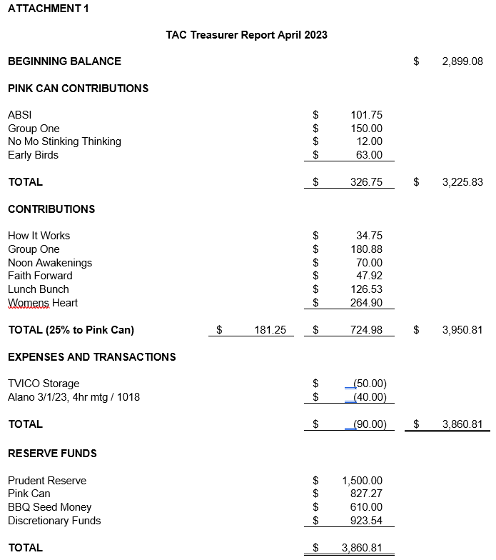

ATTACHMENT 2

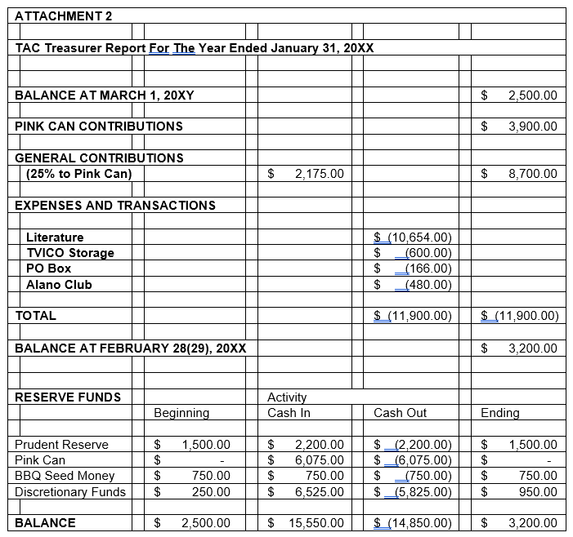
ATTACHMENT 3

Volunteer Treatment Guidelines
Treasure Valley TAC

Thank you for your willingness to participate in TAC Treatment service work! We sincerely appreciate you volunteering at our Treatment Center meetings. Please understand that the following guidelines are meant for the protection of you, the clients, the facility, your local TAC Treatment subcommittee, and AA as a whole. We have set these standards to eliminate any misunderstanding or miscommunication.

In order to volunteer you should be approved by the facility's Volunteer Coordinator or the TAC
Treatment Chairperson. You should be actively involved with the Alcoholics Anonymous program and in
contact with the Treasure Valley TAC Treatment subcommittee. It is the understanding of the meeting
coordinator that you are committed to attend regularly unless you, as the volunteer, state otherwise. If
you are ill, or cannot otherwise fulfill your commitment please notify your meeting coordinator as soon as possible.

Treatment Center Volunteers need to become familiar with any guidelines or rules of the facility(s) they are volunteering at. It is the responsibility of your facility’s Meeting Coordinator to provide you with this information. If you do not receive this information, please contact the TAC Treatment Chairperson.

- Remember, we are guests in their house! Please be respectful at all times to staff and clients. Watch your language and be respectful! Many people are offended by foul language.

- We ask that volunteers become familiar with AA GSO guidelines and suggested literature for treatment facilities. Your TAC Volunteer Coordinator or the TAC Treatment Chair will provide you with access to this information.

- Do not discuss or share information about any clients at the facility. Even if you know this person, it is a breach of their anonymity.

- No more than three (3) TAC Treatment volunteers per meeting. At least one of those volunteers should be a female unless the meeting is not a co-ed meeting.

- Meetings will begin and end on time! Volunteers who arrive late or need to leave early are asked not to attend. At the request of the facilities, we do not arrive earlier than 15 minutes before the meeting or stay later than 15 minutes after, and only access areas that are allowed.

- AA volunteers will chair the meetings and will find client volunteers to read the designated readings for the meeting.

- Dress appropriately and neatly! Some facilities have specific rules. Please abide by them. Usually, these rules consist of the following: Nothing revealing (no exposed midriffs), no inappropriate logos, no bandanas, no gang or club-related colors, no hats, no caps, and no sunglasses. Open-toed shoes are discouraged, and, in some institutions, they are not allowed.

- Absolutely no cell phone use during the meeting! Leave it in the car. Do not bring personal items into the facility. Items such as purses, briefcases, cards, letters, notes, cigarettes, and cell phones should be left at home or in your car.

Volunteer Facility Guidelines
Treasure Valley TAC Treatment

Please remember our singleness of purpose and abide by what our AA Preamble states. As alcoholics, we represent Alcoholics Anonymous, carrying a message of recovery and hope through the twelve steps. We do not represent any religious, political, or other affiliation.

Keep AA meetings positive and on topic. Sometimes it is difficult, but remember your purpose is to carry the AA message of hope to the suffering alcoholic. You are not there to share your drunkalogue! Please do not share gruesome and horrifying details of your story. It does not help anyone get sober and often will discourage people from coming to AA when they are in the general public. Remember, if scaring someone could get them sober they probably wouldn't be there in the first place!

- WE DO NOT counsel clients about medications! This is not only inappropriate but can be DANGEROUS.

- Keep your judgments and criticism to yourself. You are there to be helpful and be of service.

- If you are sick or under the weather in any way, stay home. We need you at your best and we do not want you to share what you have!

- We are not there to recruit dates, employees, roommates, sponsees, etc. Behave appropriately! We are representatives of Alcoholics Anonymous. We are there to carry the message of AA and the Twelve Steps.

- We do not sponsor clients in treatment. If asked we encourage them to get to a meeting within the first 24 hours of their release and that they find a sponsor or temporary sponsor at that meeting. Become familiar with the “Bridging The Gap” program and how it works. It is designed to provide them with a temporary contact that will assist them in getting to their first meetings and finding a sponsor.

The Following are unacceptable and may be grounds for immediate dismissal:

- Any inappropriate behavior with clients, including flirting, touching, sexual comments, or anything else that may be abusive or make a client feel uncomfortable.
- Fraternizing with the clients.
- Lack of cooperation with facility staff and, or Treatment coordinators and committee chairs.
- Repeated disregard of AA Treatment or facility guidelines.
- Any phone use during the meeting or in the facility.

Again, thank you for your service and if you have any questions or concerns, please contact the TAC Meeting Coordinator for your facility or your area Treasure Valley TAC Treatment Chairperson.

Volunteer Facility Guidelines
Treasure Valley TAC Treatment

(NOTE: This page will be signed by the volunteer and returned to the TAC Treatment Chairperson for their records.)

I, as a TAC Treatment Center volunteer, understand and will abide by the guidelines stated above. I
understand that it is my responsibility to read the AA Guidelines and recommended GSO literature for
Treatment Facilities provided to me by the TAC Treatment Committee.

____________________________________________________
Printed Name

____________________________________________________
Signature

____________________________________________________
Date

____________________________________________________
Phone #

____________________________________________________
Email Address

<<< end >>>

ATTACHMENT 4
Correction Volunteer Guidelines
Treasure Valley TAC

Thank you for your willingness to participate in TAC Correction service work! Please understand that the following guidelines are meant for the protection of you, the residents, the facility, your local TAC Correction subcommittee, and AA as a whole. We have set these standards to eliminate any misunderstanding or miscommunication.

Volunteer Requirements:
- Must be actively involved with the Alcoholics Anonymous program, have a sponsor, have/are working the 12 Steps of AA and have 2 years of continuous sobriety.
- Be in contact with the Treasure Valley TAC Corrections subcommittee.
- Must attend the IDOC PREA training for Prisons or Ada County Jail PREA training for jail. This is a Corrections mandate outside of AA. REGISTRATION LINK www.tvtac.com/trainings
- Must submit an IDOC Background check and application for prisons, and/or a separate Ada County Jail application and background check (depending on the correction facility you want to volunteer at). APPLICATION LINK www.tvtac.com/corrections
- Commit to attending regularly unless you, as the volunteer, state otherwise. If you are ill or cannot otherwise fulfill your commitment, please notify your meeting coordinator as soon as possible.
- Additional IDOC requirements summaries available at www.tvtac.com/corrections or www.idoc.idaho.gov/volunteer

AA Corrections Volunteers need to adhere to the guidelines or rules of the facility(s) they are volunteering at as covered in the PREA trainings.

- Remember, we are guests in their house! Please be respectful at all times to staff and clients. Watch your language and be respectful! Many people are offended by foul language.

- It is the volunteer's responsibility to become familiar with the AA GSO guidelines and suggested literature for corrections facilities. Your TAC Coordinator or the TV TAC Corrections Chair will provide you with access to this information.

- Do not discuss or share information about any residents at the facility. Even if you know this person, it is a breach of their anonymity.

- Due to the nature of correction facilities, meetings will begin and end on time with no exceptions.

- Meeting binders with format and readings are available so please follow the format so we have a continuous cohesive flow week after week

- WE DO NOT counsel clients about medications! This is not only inappropriate but can be DANGEROUS.

- Keep your judgments and criticism to yourself. You are there to be helpful and be of service.

- If you are sick or under the weather in any way, stay home. We need you at your best and we do not want you to share what you have!

- We do not sponsor residents. This is expressed in meeting format but if asked, we encourage them to get to a meeting within the first 24 hours of their release and that they find a sponsor or temporary sponsor at that meeting. Become familiar with the “Bridging The Gap” program and how it works.

- Per PREA regulations, we are not allowed to JayPay communicate with residents at the facility we volunteer.

- Dress appropriately and neatly and follow facility PREA training rules of nothing revealing (no exposed midriffs), no inappropriate logos (including sports teams, politics), no bandanas, no gang or club-related colors, no hats, no caps, and no sunglasses. Open-toed shoes are not allowed and please do not wear the colors of inmates for safety reasons.

- Absolutely no cell phone use during the meeting! Leave it in the car. Do not bring personal items into the facility. Items such as purses, briefcases, cards, letters, notes, cigarettes, and cell phones should be left at home or in your car.

Please remember our singleness of purpose and abide by what our AA Preamble states. As alcoholics, we represent Alcoholics Anonymous, carrying a message of recovery and hope through the twelve steps. We do not represent any religious, political, or other affiliation.

Keep AA meetings positive and on topic. Sometimes it is difficult, but remember your purpose is to carry the AA message of hope to the suffering alcoholic. You are not there to share your drunkalogue! Please do not share gruesome and horrifying details of your story. It does not help anyone get sober and often will discourage people from coming to AA when they are in the general public. Remember, if scaring someone could get them sober they probably wouldn't be there in the first place!

In addition to this, please remember the IDOC 8 Predictors of Criminal Behavior and work these into your story of how you grew from the 12-steps and fellowship of AA to overcome:
- Anti-social attitudes, values, and beliefs
- Association with criminals and isolation from pro-social people.
- Particular temperament/behavioral characteristics
- Weak social and problem-solving skills
- A history of criminal or antisocial behavior
- Negative family factors
- Low levels of vocational and educational skills
- Substance Abuse

The Following are unacceptable and may be grounds for immediate dismissal:

- Any inappropriate behavior with clients, including flirting, touching, sexual comments, or anything else that may be abusive or make a client feel uncomfortable.
- Fraternizing with the clients.
- Lack of cooperation with facility staff and, or Treatment coordinators and committee chairs.
- Repeated disregard of AA Treatment or facility guidelines.
- Any phone use during the meeting or in the facility.

Again, thank you for your service and if you have any questions or concerns, please contact the TAC Meeting Coordinator for your facility or your area Treasure Valley TAC Treatment Chairperson.
Correction Volunteer Guidelines
Treasure Valley TAC

(NOTE: This page will be signed by the volunteer and returned to the TAC Corrections Chairperson for their records.)

I, as a volunteer at___ ________________ on ___ ________, understand and will abide by the guidelines stated above. I understand that it is my responsibility to read the AA Guidelines and recommended GSO literature for Correction Facilities provided to me by the TAC Corrections Committee.

____________________________________________________
Printed Name

____________________________________________________
Signature

____________________________________________________
Date

____________________________________________________
Phone #

____________________________________________________
Email Address

<<< end >>>

